**Module -3**

**1. Different Types of Cloud Storage**

“Cloud storage solutions are essential for modern data management, offering various options to suit different needs:

Public Cloud Storage: This type of storage is provided by third-party service providers over the internet. Examples include Google Drive, Dropbox, and Microsoft OneDrive. Public cloud storage is scalable, cost-effective, and easy to use, making it ideal for individuals and small businesses. However, it may raise concerns about data security and privacy since the data is stored on shared infrastructure.

Private Cloud Storage: Unlike public cloud storage, private cloud storage is dedicated to a single organization. It can be hosted on-premises or by a third-party provider. Private cloud storage offers enhanced security, control, and customization, making it suitable for businesses with sensitive data or strict regulatory requirements. The downside is that it can be more expensive and complex to manage.

Hybrid Cloud Storage: This approach combines public and private cloud storage, allowing data and applications to be shared between them. Hybrid cloud storage provides the flexibility to keep sensitive data in a private cloud while leveraging the scalability and cost benefits of the public cloud for less critical data. This model supports dynamic workloads and offers a balanced approach to data management.

Community Cloud Storage: This type of storage is shared among several organizations with common concerns, such as security, compliance, or industry-specific requirements. Community cloud storage can be managed internally or by a third-party provider. It offers a collaborative environment while maintaining a higher level of security and compliance than public cloud storage.”

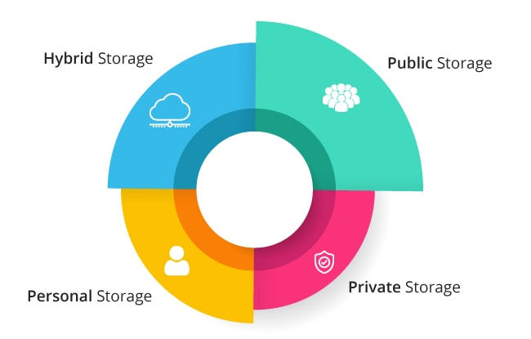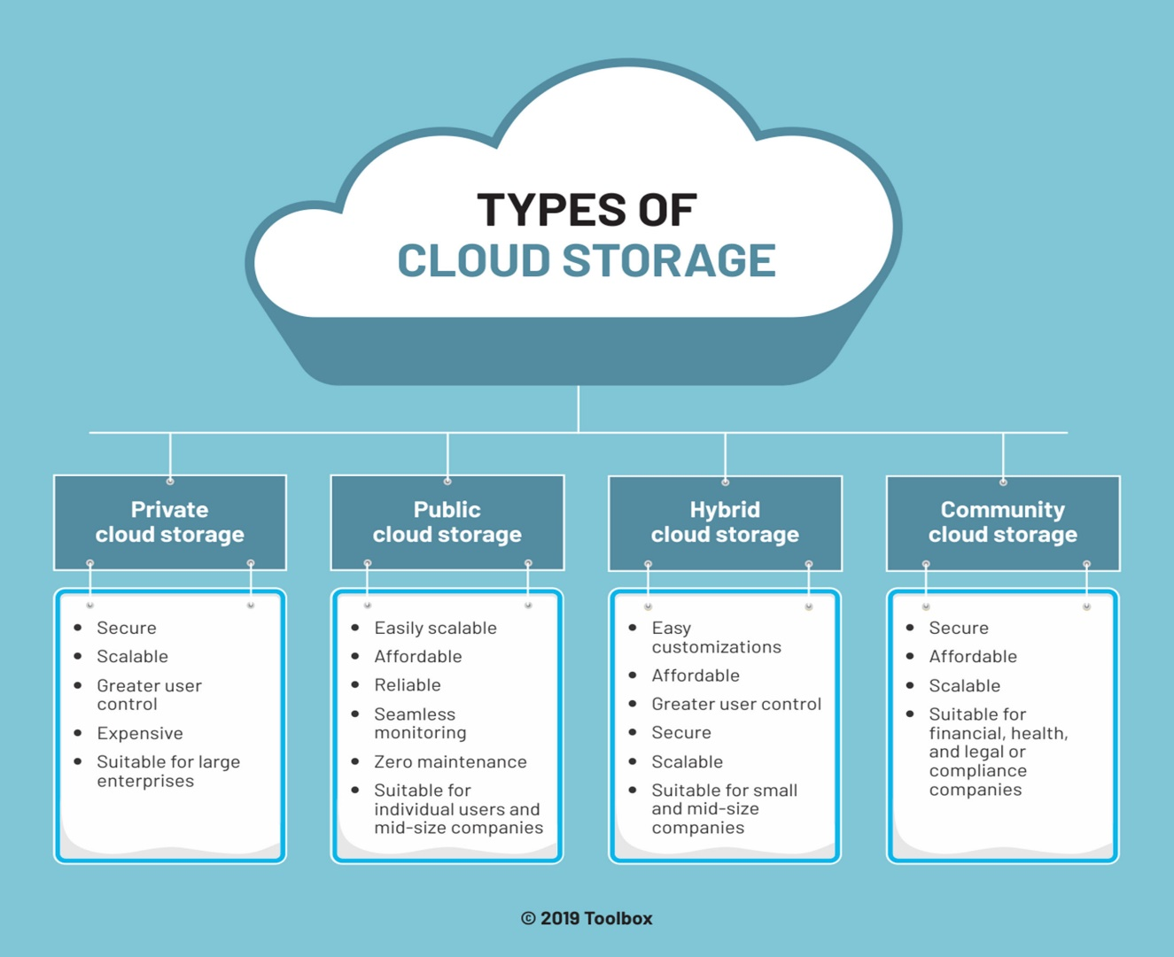

**2. Role-Based Access Control (RBAC), Identity and Access** “Management (IAM), and Multi-Factor Authentication (MFA)

These concepts are crucial for securing access to systems and data:

Role-Based Access Control (RBAC): RBAC is a method of restricting system access to authorized users based on their roles within an organization. Each role is assigned specific permissions, and users are granted roles according to their responsibilities. This approach simplifies access management by grouping permissions into roles rather than assigning them individually. For example, an employee in the finance department might have access to financial records but not to HR data. RBAC helps enforce the principle of least privilege, reducing the risk of unauthorized access.

Identity and Access Management (IAM): IAM encompasses the policies, processes, and technologies used to manage digital identities and control access to resources. It includes user authentication (verifying identity), authorization (granting access), and accounting (tracking user activity). IAM systems ensure that the right individuals access the right resources at the right times for the right reasons. They often integrate with directory services, single sign-on (SSO) solutions, and access governance tools to provide a comprehensive security framework.

Multi-Factor Authentication (MFA): MFA enhances security by requiring users to provide two or more verification factors to access a system. These factors typically include something the user knows (password), something the user has (security token or smartphone), and something the user is (biometric verification like fingerprints or facial recognition). By combining multiple factors, MFA significantly reduces the risk of unauthorized access, even if one factor (e.g., a password) is compromised.”

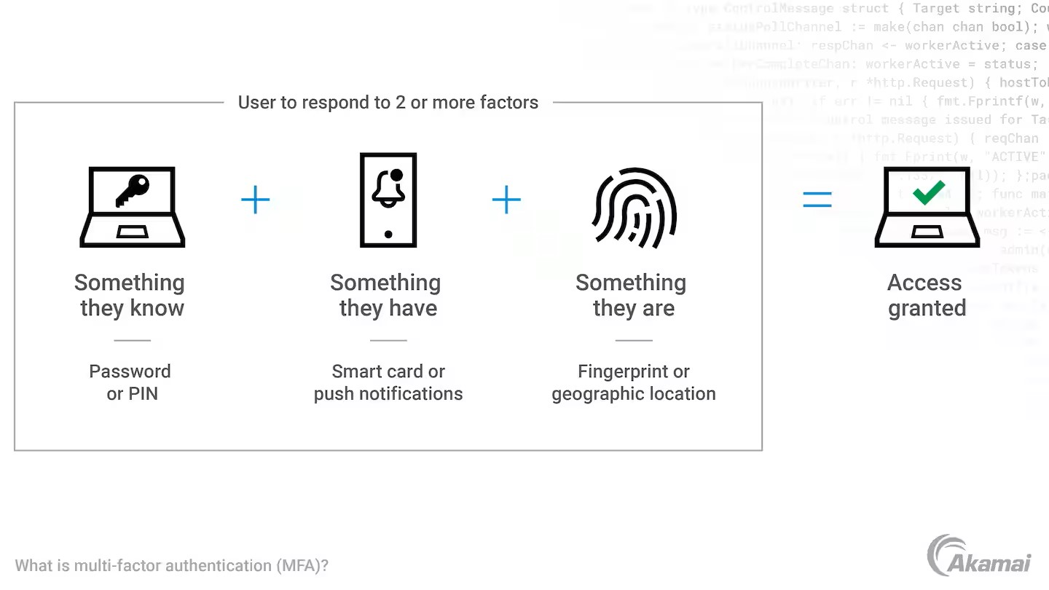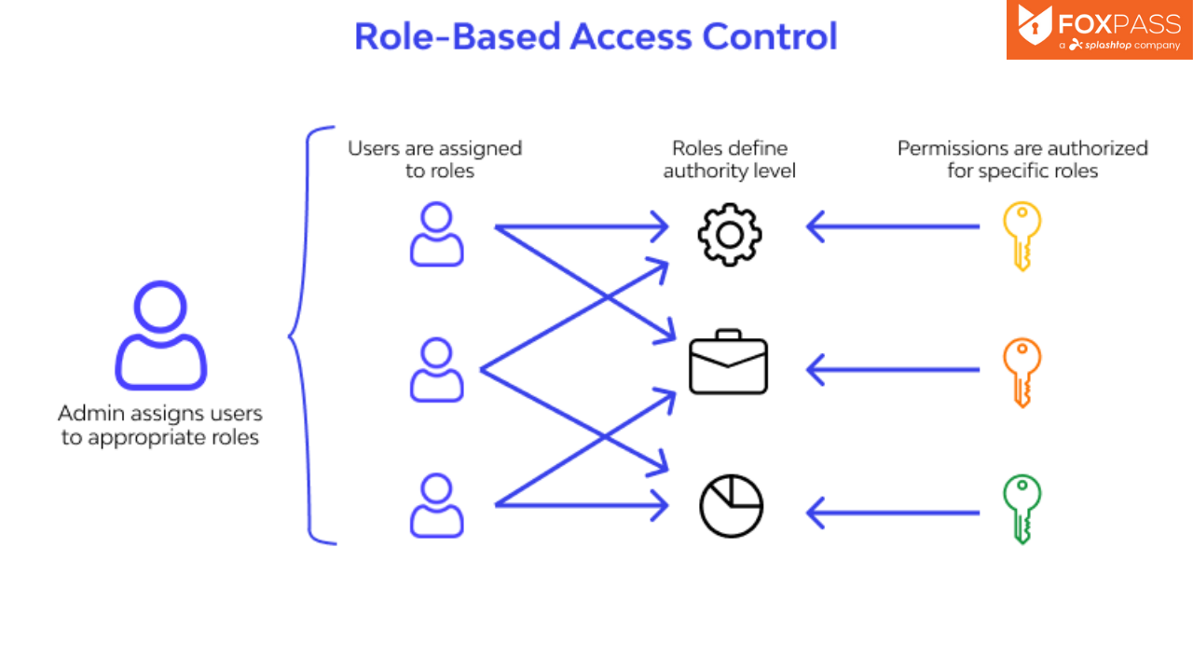

**3. Physical and Virtual Host Allocation**

“Understanding the difference between physical and virtual host allocation is key to managing IT infrastructure:

Physical Host Allocation: This involves assigning physical servers to run applications and services. Each physical server has its own dedicated resources, such as CPU, memory, and storage. Physical host allocation provides high performance and reliability but can be costly and less flexible. It is often used for critical applications that require dedicated resources and minimal latency.

Virtual Host Allocation: Virtualization technology allows multiple virtual machines (VMs) to run on a single physical server. Each VM operates as an independent server with its own operating system and resources. Virtual host allocation offers greater flexibility, scalability, and cost efficiency. It enables better resource utilization by allowing multiple VMs to share the same physical hardware. This approach is widely used in cloud computing environments to provide scalable and on-demand resources.”

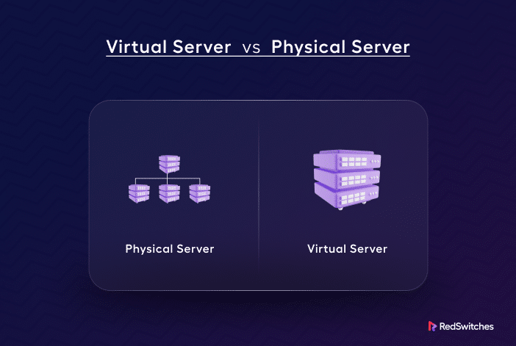

**4. How to Access Resources of Cloud Computing**

“Accessing cloud resources can be done through various methods:

Web Interfaces: Most cloud service providers offer web-based dashboards and management consoles. These interfaces allow users to manage and monitor their cloud resources, such as virtual machines, storage, and databases, through a graphical user interface (GUI). Examples include the AWS Management Console, Azure Portal, and Google Cloud Console.

APIs (Application Programming Interfaces): APIs enable developers to interact with cloud services programmatically. They provide a set of functions and protocols for accessing and managing cloud resources. APIs are essential for automating tasks, integrating cloud services with other applications, and building custom solutions. Cloud providers offer comprehensive API documentation and SDKs (Software Development Kits) to facilitate development.

Command-Line Tools: Command-line interfaces (CLIs) like AWS CLI, Azure CLI, and Google Cloud SDK allow users to manage cloud resources from the command line. CLIs provide powerful scripting capabilities, enabling users to automate repetitive tasks, deploy infrastructure as code, and perform bulk operations. They are particularly useful for advanced users and DevOps professionals.”

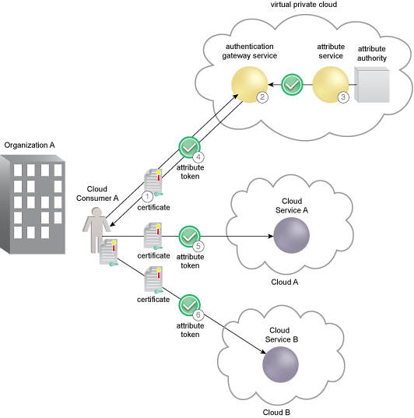

**5. Types of Backup in Cloud**

“Cloud backup solutions offer various types of backups to ensure data protection and recovery:

Full Backup: A full backup involves creating a complete copy of all data. It provides the most comprehensive protection but can be time-consuming and resource-intensive. Full backups are typically performed periodically (e.g., weekly or monthly) to ensure a complete data snapshot.

Incremental Backup: Incremental backups only copy the data that has changed since the last backup (whether full or incremental). This approach reduces backup time and storage requirements. However, restoring data may take longer because it requires the last full backup and all subsequent incremental backups.

Differential Backup: Differential backups copy all data that has changed since the last full backup. Unlike incremental backups, differential backups do not depend on previous differential backups. This approach strikes a balance between backup time and restore time, as it requires only the last full backup and the latest differential backup for restoration.

Cloud-to-Cloud Backup: This involves backing up data from one cloud service to another. It provides an additional layer of protection by ensuring that data is not solely reliant on a single cloud provider. Cloud-to-cloud backup solutions are useful for organizations using multiple cloud services or seeking to mitigate the risk of provider outages.”

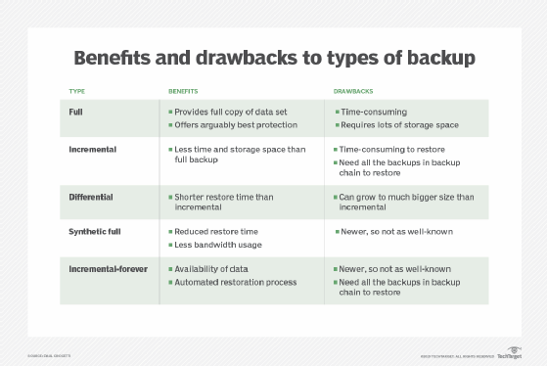

**6. What is Disaster Recovery?**

“Disaster recovery (DR) is a critical aspect of business continuity planning, ensuring that an organization can recover and continue operations after a disruptive event.

Purpose: The primary goal of disaster recovery is to minimize downtime and data loss, ensuring that critical systems and data are quickly restored after a disaster. Disasters can include natural events (e.g., earthquakes, floods), human-induced incidents (e.g., cyberattacks, hardware failures), and other disruptions (e.g., power outages).

Components:

Backup: Regularly creating copies of data to ensure it can be restored in case of loss or corruption. Backups should be stored in multiple locations, including offsite or in the cloud, to protect against local disasters.

Recovery Plan: A detailed plan outlining the steps to recover data, systems, and operations. The plan should include roles and responsibilities, communication protocols, and procedures for restoring critical systems.

Testing: Regularly testing the disaster recovery plan to ensure it works effectively and that staff are familiar with their roles. Testing helps identify gaps and areas for improvement, ensuring the plan remains up-to-date and effective.

Types of DR:

Cold Site: A backup site with no current data or systems running. It requires setup time to become operational. Cold sites are cost-effective but have longer recovery times.

Warm Site: A backup site with some pre-installed hardware and software, but not fully operational. It requires less setup time than a cold site and offers a balance between cost and recovery time.

Hot Site: A fully operational backup site that can take over immediately in case of a disaster. Hot sites are the most expensive but provide the shortest recovery times, making them suitable for mission-critical applications.

Benefits: Implementing a disaster recovery plan ensures business continuity, protects against data loss, and helps maintain customer trust. It also supports regulatory compliance and reduces the financial impact of disruptions.”

